Project Design Phase-II
Data Flow Diagram & User Stories

Team ID | SWTID-2026-1448
Project Name | Import Data using Transform Maps (Spreadsheet)

Data Flow Diagrams:
A Data Flow Diagram (DFD) visually represents how information moves through a system. In this project, it shows how employee data is uploaded from a spreadsheet, staged in a ServiceNow Import Set, processed through a Transform Map, stored in the Employee Test table, and displayed in reports and dashboards.
DFD Level 0 (Simplified)
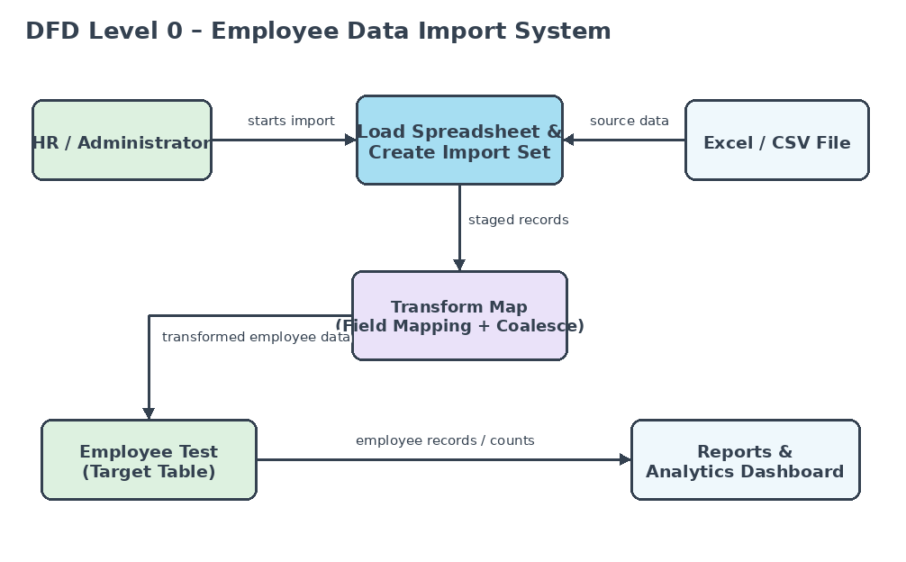

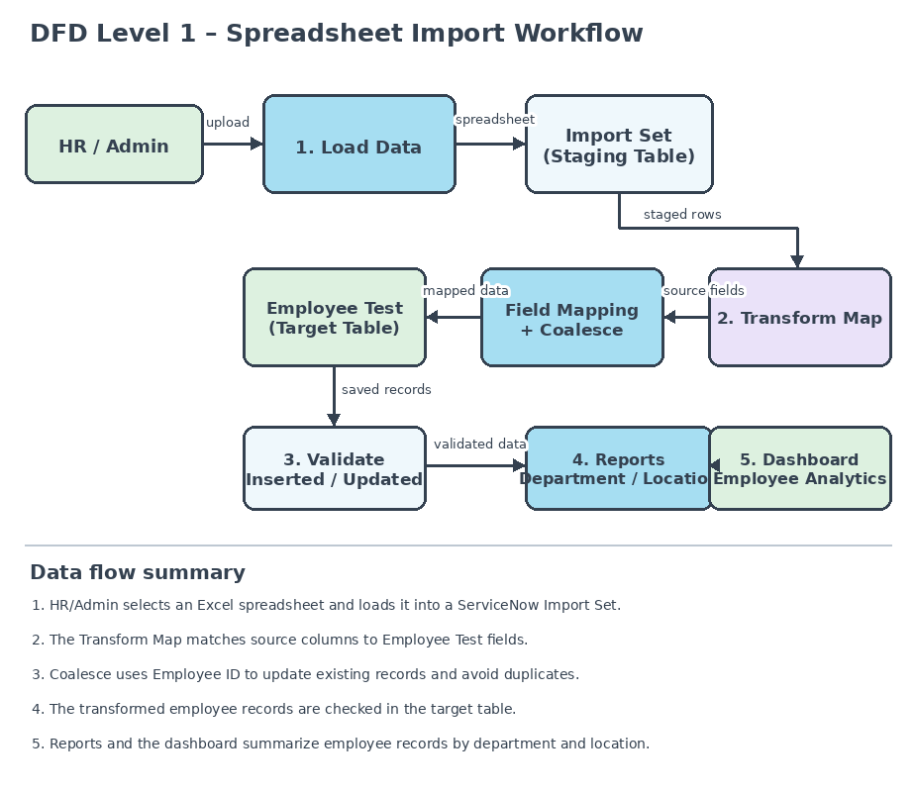

User Stories
The following user stories describe the requirements for the ServiceNow employee data import project.
User Type | Functional Requirement (Epic) | User Story Number | User Story / Task | Acceptance criteria | Priority | Release
HR / Administrator | Spreadsheet Upload | USN-1 | As an HR user, I can upload an Excel file with employee details. | The file loads into the Employee Import staging table. | High | Sprint-1
 | Import Set | USN-2 | As an administrator, I can review uploaded rows in the Import Set. | The import set is created and rows are available for transformation. | High | Sprint-1
 | Field Mapping | USN-3 | As an administrator, I can map spreadsheet columns to Employee Test fields. | Required source and target fields are mapped and saved. | High | Sprint-1
 | Data Transformation | USN-4 | As an administrator, I can run the Transform Map to import employee data. | Valid employee records appear in Employee Test. | High | Sprint-1
 | Duplicate Prevention | USN-5 | As an administrator, I can use Employee ID as the coalesce field. | Existing IDs are updated instead of duplicated. | High | Sprint-2
HR / Web user | Employee Records | USN-6 | As an authorized user, I can view imported employee records. | Employee ID, name, email, department, and location are visible. | Medium | Sprint-2
Administrator | Department Report | USN-7 | As an administrator, I can view employees grouped by department. | The report displays department-wise employee counts. | Medium | Sprint-2
 | Location Report | USN-8 | As an administrator, I can view employees grouped by location. | The report displays location-wise employee counts. | Medium | Sprint-2
 | Dashboard & Validation | USN-9 | As an administrator, I can view reports and check import history. | Dashboard shows reports; history shows inserted, updated, and ignored rows. | Medium | Sprint-2

